Technical Memorandum
Water Temperature Modeling Platform: Estimation of Uncertainty – Protocols (DRAFT)
Central Valley Project Water Temperature Modeling Platform
California-Great Basin Region
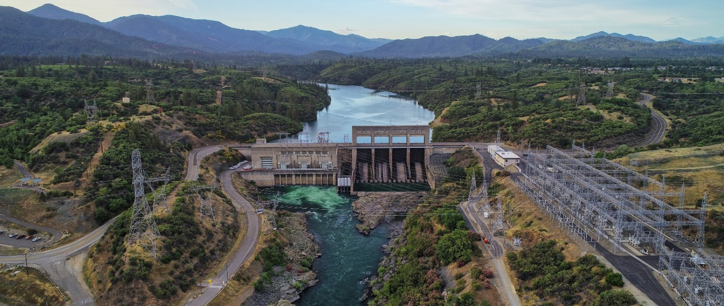

Mission Statements
The U.S. Department of the Interior protects and manages the Nation’s natural resources and cultural heritage; provides scientific and other information about those resources; and honors its trust responsibilities or special commitments to American Indians, Alaska Natives, and affiliated Island Communities.
The mission of the Bureau of Reclamation is to manage, develop, and protect water and related resources in an environmentally and economically sound manner in the interest of the American public.

Water Temperature Modeling Platform: Estimation of Uncertainty – Protocols (DRAFT)
Central Valley Project Water Temperature Modeling Platform
California-Great Basin Region
prepared by
United States Department of the Interior Bureau of Reclamation
California-Great Basin
With Technical Support by:
Watercourse Engineering, Inc.

Cover Photo: Keswick Dam on the Sacramento River by John Hannon

Contents
Page
Chapter 1 Introduction 1-1
Chapter 2 Protocols 2-1
Forecasting Uncertainty 2-2
Chapter 3 Protocol – Forecasting Process Uncertainty 3-1
Approach 3-1
Type A: Calibration 3-2
Type B: TCD Logic 3-3
Type C: Boundary Conditions – Flow 3-3
Type D: Boundary Conditions – Meteorology 3-7
Other Assumptions 3-8
Results: ResSim 3-9
Results: CE-QUAL-W2 3-20
March 1 Start Date 3-21
May 1 Start Date 3-21
Shasta Lake Thermal Profile 3-24
Summary 3-25
Chapter 4 Conclusion 4-1
Chapter 5 References 5-1

Figures
Figure 2-1. Model uncertainty as a function of calibration and application error. 2-1
Figure 3-1. Pattern inflow hydrograph for Shasta Lake. 3-3
Figure 3-2. Shasta Lake inflow for historic daily average, historic monthly average, and disaggregate daily (from historic monthly average) (top), and Shasta Dam total release for historic daily average, historic monthly average (bottom): 2006. 3-4
Figure 3-3. Shasta Lake tributary inflow for McCloud River, Pit River, Sacramento River, and Sulanharas Creek inflow distribution (top to bottom) showing historic daily average and regression on disaggregated Shasta Lake inflow: 2006. 3-5
Figure 3-4. Shasta Lake tributaries: Sacramento, McCloud, and Pit Rivers inflow temperatures for historical average, estimated based on regressions using forecast inflow and historical meteorology (air temperature) and forecast meteorology (air temperature): 2010-2014. 3-7
Figure 3-5. Historical and resampled meteorology applied to the Type D forecast uncertainty determine Shasta Lake inflow temperatures for the Sacramento, McCloud, and Pit Rivers, estimated based on regressions using forecast inflow and historical meteorology (air temperature) and as the forecast meteorology boundary condition for cloud cover, relative humidity, wind speed, air temperature and solar radiation (top to bottom): 2006. 3-8
Figure 3-6. Diagram of model uncertainty estimation for ResSim WTMP. 3-9
Figure 3-7. Example simulation temperature results for all simulation types, Shasta Dam outflow: 2014. 3-10
Figure 3-8. Example Simulation Result for all simulation types, Shasta Outflow Temperature: 2018. 3-11
Figure 3-9. Example Observed and Modeled (Forecast) Shasta TCD gate configuration: 2014. 3-11
Figure 3-10. Shasta Dam outflow temperature and bias (ºF) Type B Simulation Results, 2000-2019 March Start. Top panel: Historical (solid) and Modeled (dashed) daily mean temperatures. Bottom panel: Difference in daily mean temperature, Simulated – Historical. 3-12
Figure 3-11. Shasta Dam outflow Temperature and bias (ºF) Type C Simulation Results, 2000-2019 March Start. Top panel: Historical (solid) and Modeled (dashed) daily mean temperatures. Bottom panel: Difference in daily mean temperature, Simulated – Historical. 3-13
Figure 3-12. Shasta Dam outflow temperature and bias (ºF) Type D Simulation Results, 2000-2019 March Start. Top panel: Historical (solid) and Modeled (dashed) daily mean temperatures. Bottom panel: Difference in daily mean temperature, Simulated – Historical. 3-14
Figure 3-13. Shasta Dam outflow temperature monthly confidence intervals by simulation type. Vertical height of monthly box = 95% confidence interval. Numbers below box show p-value of normality test. Samples are the simulated daily mean temperature minus historical daily mean. The top, middle, and bottom panels and for March, May, and July start simulations, respectively. 3-15
Figure 3-14. Shasta Dam outflow temperature monthly mean bias by simulation type. Samples are the simulated daily mean temperature minus historical daily mean. The top, middle, and bottom panels and for March, May, and July start simulations, respectively. 3-16
Figure 3-15. Keswick Dam outflow temperature monthly confidence intervals by simulation type. Vertical height of monthly box = 95% confidence interval. Numbers below box show p-value of normality test. Samples are the simulated daily mean temperature minus historical daily mean. The top, middle, and bottom panels and for March, May, and July start simulations, respectively. 3-17
Figure 3-16. Keswick Dam outflow temperature monthly mean bias by simulation type. Samples are the simulated daily mean temperature minus historical daily mean. The top, middle, and bottom panels and for March, May, and July start simulations, respectively. 3-18
Figure 3-17. Sacramento River above Clear Creek Temperature monthly confidence intervals by simulation type. Vertical height of monthly box = 95% confidence interval. Numbers below box show p-value of normality test. Samples are the simulated daily mean temperature minus historical daily mean. The top, middle, and bottom panels and for March, May, and July start simulations, respectively. 3-19
Figure 3-18. Sacramento River above Clear Creek Temperature monthly mean bias by simulation type. Samples are the simulated daily mean temperature minus historical daily mean. The top, middle, and bottom panels and for March, May, and July start simulations, respectively. 3-20
Figure 3-19. Daily average Shasta Dam release temperature (a) for Type A, B, C, and D forecast uncertainty compared to the measured temperature, and (b) for differences between measured and Type A, B, C, and D forecast uncertainty: March 1, 2018 start date. 3-22
Figure 3-20. Monthly average Shasta Dam release temperature for Type A, B, C, and D forecast uncertainty minus measured release temperature for a March 1, 2018 start date. 3-22
Figure 3-21. Daily average Shasta Dam release temperature (a) for Type A, B, C, and D forecast uncertainty compared to the measured temperature, and (b) for differences between measured and Type A, B, C, and D forecast uncertainty for a May 1, 2018 start date. 3-23
Figure 3-22. Monthly average Shasta Dam release temperature for Type A, B, C, and D forecast uncertainty minus measured release temperature for a May 1, 2018 start date. 3-23
Figure 3-23. Monthly Shasta Lake profiles June 1 through October: March 1, 2018 start date. 3-25

Tables
Table 3-1. Summary of simulation set boundary conditions for cumulative forecast uncertainty analysis. 3-2
Table 3-2. Shasta Lake modeled tributary inflow weights by month (weight_{trib month}). 3-5
Table 3-3. Shasta Lake tributary inflow temperature regressions coefficients for the Sacramento, McCloud, and Pit Rivers, coefficient of determination, and root-mean squared (RMS) error. 3-6

Abbreviations and Acronyms
CDEC California Data Exchange Center
CIMIS California Irrigation Management Information System
CPP Community Participation Plan
CVP Central Valley Project
DWR California Department of Water Resources
DFW California Department of Fish and Wildlife
GUI Graphical User Interface
NWS National Weather Service
QA Quality Assurance
RAWS Remote Automated Weather Station
Reclamation U.S. Department of the Interior, Bureau of Reclamation
TCD Temperature Control Device
USFWS United States Fish and Wildlife Service
USGS United States Geological Service
WTMP Water Temperature Modeling Platform

This page intentionally left blank.

Introduction
Flow and water temperature simulation models are useful and necessary tools to support resource managers in their understanding of temperature dynamics in U.S. Department of the Interior, Bureau of Reclamation (Reclamation) Central Valley Project (CVP) reservoirs and downstream river reaches. Such tools support evaluation of how operational decisions and various influencing factors can affect water temperature in reservoirs and rivers, and the resulting potential impacts to fishery species that are sensitive to water temperature.
Flow and water temperature modeling tools to support operational decision-making provide a means to assess strategies and define objectives for water temperature management. Water temperature modeling frameworks are used to forecast and assess future conditions for real-time, seasonal operations, and biological assessments to achieve goals. Reclamation’s objective for the development of the Water Temperature Modeling Platform (WTMP) is the effective and efficient management of resources for downstream regulatory and environmental requirements within the context of an uncertain environment. This report is a companion to Reclamation (2023g) that identifies sources of uncertainty and assesses protocols for characterizing and communicating uncertainty and includes two specific elements: development of estimates and/or estimation procedures for uncertainty in datasets, and development of estimates and/or estimation procedures for translating uncertainty through modeling framework to model results.

This page intentionally left blank.

Protocols
Sources of uncertainty were identified in Reclamation (2023g). Herein, discussion will focus on development of estimates and/or estimation procedures for assessing uncertainty in modeling data sets and uncertainty in the modeling framework model application. The WTMP development and its uncertainty investigation are approached from a global perspective. The “calibration mode” of modeling included quantification of error associated with all previous stages (conceptualization, development, data) and model parameter estimation (calibration) were assessed using model performance metrics to determine the fitness and acceptability of the calibrated model. Specifically, errors incurred through the individual steps of conceptualization, model development, and data development are evaluated in aggregate during the model parameter estimation and calibration process. Through ongoing applications of the WTMP and associated models, additional insights associated with the effects of uncertainty stemming from model calibration may be examined for potential refinements, improved process representation, and additional data acquisition.
Additional errors, beyond that associated with calibration, occur in applications of the models. Model applications include forecasting, long-term planning or other (e.g., hindcast, validation). Uncertainty of the calibrated model is inherited and contributes to overall uncertainty of model application results (Figure 2-1).
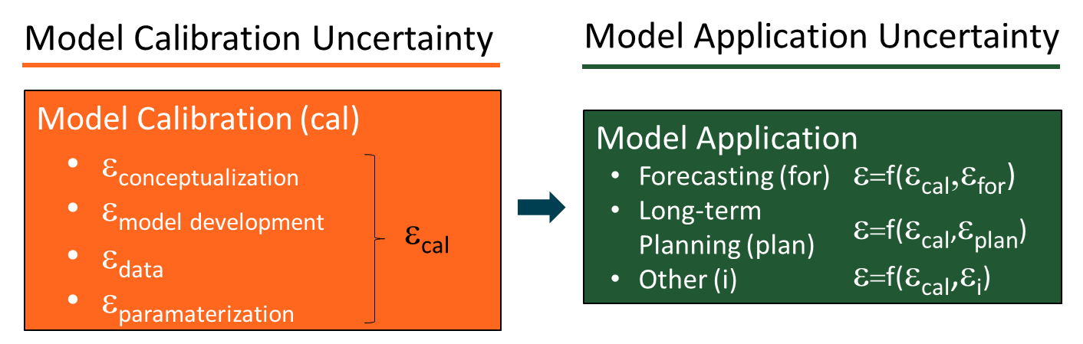
Figure 2-1. Model uncertainty as a function of calibration and application error.
Model applications can represent many conditions. Applications currently represented in the WTMP include validation and hindcasts, seasonal temperature forecast, iterative simulations (ensemble simulation, position analysis, sensitivity), and long-term planning analyses (Reclamation 2023f). Application uncertainty associated with these types of model simulations varies. Validation and hindcast applications utilize historic information and observations using the calibrated model, thus uncertainty associated with these tasks is consistent with calibration error. Forecasting error is due to errors in the input data estimates (a process external to the modeling process) and errors related to how the forecast is represented in the model. Forecast model inputs include boundary conditions for flow, operations, water temperature, and meteorology. This is generally similar for both iterative simulations and long-term planning, i.e., boundary conditions data are developed external to the model and model process assumptions and approaches introduce model uncertainty.
Herein, the forecast application is used as an example of a protocol to assess model uncertainty and then use the disaggregation approach as protocol for long-term planning that can be done later.

Forecasting Uncertainty
Calibration error (encompassing conceptualization, model development estimation, data error, and model parameter error) is intrinsic to the model (ecal in Figure 2-1) and contributes to overall uncertainty in model application results. Forecasting uncertainty originates from the forecast boundary conditions (flow and operations forecasts, meteorology forecasts, and associated inflow water temperature estimates) and the forecasting process and assumptions used to translate forecast boundary conditions to model input and modeling assumptions (efor in Figure 2-1). Model calibration and forecasting uncertainty may accumulate or cancel one another in space and time.
Hydrology, operations, and meteorology forecasts are an active and important area of interest and research, providing valuable insight to resource managers and decision makers. Because these forecasts are developed external to the modeling platform, the quality, or skill, of these forecasts is not explicitly investigated herein. Further, forecasting methods are currently an active area of research showing considerable progress in making more accurate estimates further into the future (Reclamation 2023g). As this and other new information become more accessible, the WTMP can be used to explore additional approaches into how error in external flow and meteorological forecasts is reflected in model results. Herein, forecasting process and assumptions used to translate forecast boundary conditions to model input and modeling assumptions are explored.

Protocol – Forecasting Process Uncertainty
A series of “retrospective forecast” simulations are performed that test how certain processes and assumptions (and approximations) introduced by forecast boundary condition processing and automatic TCD gate selection affect the accuracy of model predictions. The approach can be applied, in whole or part, to the other applications listed above. The seasonal forecasting application was selected as the example herein because this model application includes a wide range of assumptions that can readily be tested in the WTMP.

Approach
A forecasting process was outlined in Reclamation (2023g) identifying potential sources of uncertainty, Specifically, the set of simulations includes four uncertainty types (see Table 3-1):
- Calibrated Model Uncertainty – historical boundary conditions were used as prepared for the calibration/validation simulation. This represents a baseline condition where initial conditions, boundary conditions, TCD gate settings are known and based on the best available measured data, and the model uncertainty is defined by the calibration (e.g., difference between the simulated and observed).
- Selective Withdrawal Logic Uncertainty – uncertainty associated with model determined gate settings for the TCD (Shasta Dam) versus historical gate settings. Type B uncertainty includes calibration uncertainty.
- Flow Disaggregation Uncertainty – Type C includes changes from Type B, above, plus processing of reservoir inflows and releases in a manner similar to the process used in the operations forecast monthly data. Reservoir inflow temperatures were subsequently estimated based on the downscaled daily inflow time series and the historical meteorologic record.
- Meteorology Forecast Uncertainty – Type D uncertainty includes all changes from Type C, above, plus an estimated meteorology forecast. Reservoir inflow temperatures were subsequently estimated based on the downscaled daily inflow time series and the estimated meteorology forecast.
The process is summarized in Table 3-1.
Table 3-1. Summary of simulation set boundary conditions for cumulative forecast uncertainty analysis.
Boundary Condition | Base Model Uncertainty  (Type A) | Uncertainty Associated TCD Operation  (Type B) | Uncertainty Associated with Monthly Average Flows  (Type C) | Uncertainty Associated with Estimated Meteorology  (Type D)
Temperature Target | Historical | Weekly or monthly average of historical | Weekly or monthly average of historical | Weekly or monthly average of historical
TCD Shutter Operation | Historical | Model determined | Model determined | Model determined
Inflow | Historical | Historical | Downscaled daily from monthly average of historical | Downscaled daily from monthly average of historical
Reservoir Releases | Historical | Historical | Monthly average of historical | Monthly average of historical
Meteorologic Data | Historical | Historical | Historical | Each month selected from historical record based on monthly average air temperature
Inflow Temperature | Historical | Historical | Derived from downscaled monthly inflow and historical meteorology | Derived from downscaled monthly inflow and estimated meteorology
Forecast simulations were performed starting on the first of each month from March through July of each year in the historical data period used for calibration (2000 to 2019). The uncertainty analysis was performed with HEC-ResSim for 20 years and includes computation of error metrics, and reporting figures. The identical process was also completed for CE-QUAL-W2 at Shasta Lake and Keswick Reservoir for a single year (due to computational times) to illustrate similar application of the models.

Type A: Calibration
The calibration simulation and associated uncertainty discussed in Reclamation (2023d, g) was used with one modification: the initial reservoir temperature profile to start each simulation was based on historical observations on the first day of the start month. If a measured profile was available within 10 days of the first day of the start month, the measured profile was used. Otherwise, calibration ResSim model results were used to represent the first of month reservoir temperature profile. Initial river temperatures were set to 50ºF (10ºC) and were replaced by modeled temperatures representing upstream flow and temperature boundary conditions and meteorological forcings in approximately one day.

Type B: TCD Logic
A time series of weekly average water temperatures was developed based in the observed Shasta Dam outflow temperature (i.e., from the calibration simulation). Subsequently, Shasta Dam TCD operations were controlled by the selective withdrawal (blending) model logic included in ResSim or CE-QUAL-W2 (additional details included in the appendices of Reclamation (2023g)). Type B uncertainty includes calibration uncertainty and deviates from the Type A error because of the specified initial conditions on the first of each month.

Type C: Boundary Conditions – Flow
Boundary conditions for flow includes Type A and B errors and errors that arise from disaggregating monthly average flows to daily average flows, distributing total inflows among tributary streams, and estimating inflow temperatures. The observed reservoir daily inflows and releases from the historic period were used to calculate a monthly average value (aggregated). This monthly inflow was disaggregated back to daily inflows using the standard forecasting process and approach employed by Reclamation. Specifically, inflows, release schedules, and diversion flows are disaggregated from one-month (acre-feet per month) to one-day (cfs) values. For Shasta Lake, Trinity Lake, and Whiskeytown Lake inflows, Reclamation provided a temporal disaggregation pattern as a daily hydrograph (Figure 3-1). To apply the pattern to a particular day in the month (q_{day}), the ratio of each month’s volume in the pattern hydrograph (Σq_{day-pattern}) to the volume given in the operation spreadsheet (Volume_{month}) is calculated, and the pattern hydrograph value for the specified day in that month (q_{day-pattern}) is scaled by the volume ratio:
$q_{day}= q_{day-pattern}\left({Volume}_{month} /\sum_{month}{q_{day-pattern}}\right)$ (1)
Where no pattern hydrograph is available, volumes are converted to uniform flow rates for each month.
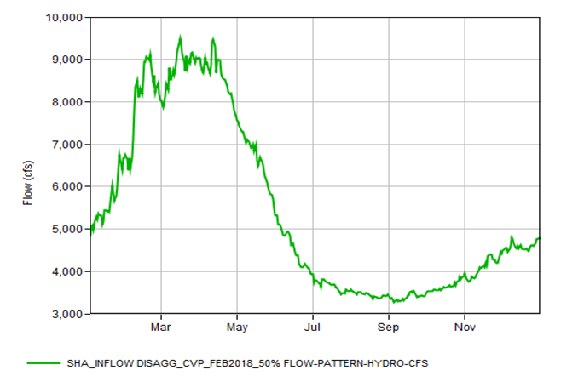
Figure 3-1. Pattern inflow hydrograph for Shasta Lake.
The result was a daily time series that differed from the historic period in magnitude and distribution, but was equivalent to the monthly average (i.e., conserved mass). Shasta Dam outflows are typically forecast and modeled as a monthly average and thus historic outflow data were averaged to monthly values and used in the forecast. The Shasta Lake inflow for historic daily average, historic monthly average, and disaggregate daily (from historic monthly average), and Shasta Dam total release for historic daily average, historic monthly average for 2006 is shown in Figure 3-2. The total Shasta Lake inflow was spatially disaggregated to individual tributaries. Flow records for the years 2000-2019 on the tributaries were reviewed and weights calculated by month distribute the total inflow into the reservoirs onto the individual tributary inflows. Weights were calculated by summing all daily flows (q_{trib day}) in a month on a tributary for all years and dividing that volume by the sum of all flows in the same month on all tributaries for all years.
${weight}_{trib month}=\sum_{all years}{\sum_{month}{q_{trib day}}}/\sum_{all years}{\sum_{month}{\sum_{all tribs}{q_{trib day}}}}$ (2)
The disaggregated monthly weights for Shasta Lake tributaries (Table 3-2) and an example of the four Shasta Lake tributaries are shown in Figure 3-3. Trinity Lake was addressed in a similar manner.
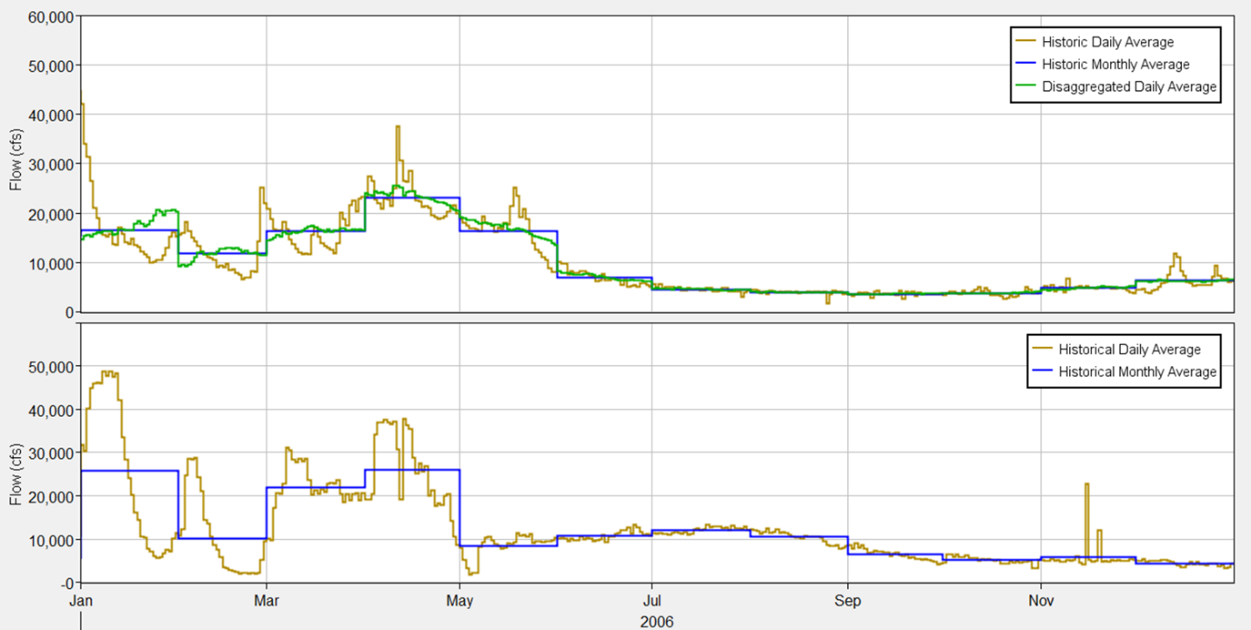
Figure 3-2. Shasta Lake inflow for historic daily average, historic monthly average, and disaggregate daily (from historic monthly average) (top), and Shasta Dam total release for historic daily average, historic monthly average (bottom): 2006.
Table 3-2. Shasta Lake modeled tributary inflow weights by month (weight_{trib month}).
Month | Sacramento River | McCloud River | Sulanharas Creek | Pit River
1 | 0.21277 | 0.13857 | 0.03703 | 0.61163
2 | 0.22433 | 0.15755 | 0.04268 | 0.57545
3 | 0.22118 | 0.13919 | 0.04096 | 0.59867
4 | 0.23103 | 0.12980 | 0.03960 | 0.59957
5 | 0.22998 | 0.10707 | 0.03705 | 0.62590
6 | 0.17451 | 0.09743 | 0.02404 | 0.70403
7 | 0.09650 | 0.09913 | 0.01009 | 0.79428
8 | 0.07416 | 0.09462 | 0.00693 | 0.82429
9 | 0.06613 | 0.09797 | 0.00603 | 0.82987
10 | 0.08593 | 0.11194 | 0.00968 | 0.79245
11 | 0.11000 | 0.10935 | 0.01355 | 0.76710
12 | 0.20857 | 0.15180 | 0.03899 | 0.60063

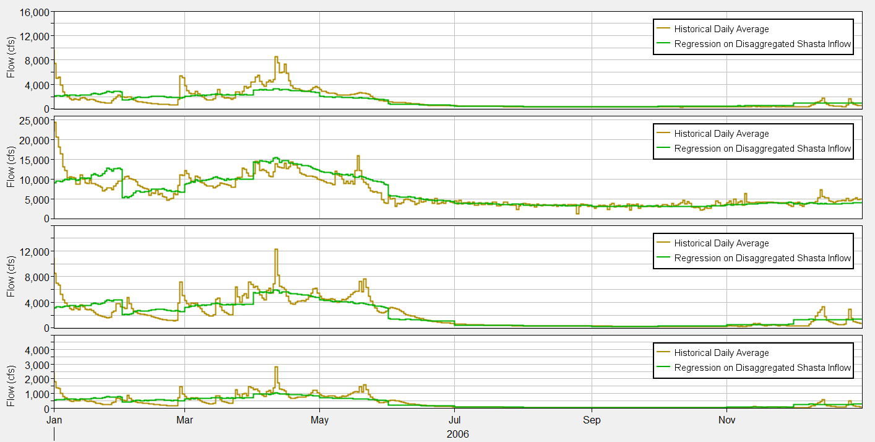
Figure 3-3. Shasta Lake tributary inflow for McCloud River, Pit River, Sacramento River, and Sulanharas Creek inflow distribution (top to bottom) showing historic daily average and regression on disaggregated Shasta Lake inflow: 2006.

Reservoir inflow temperatures were estimated using multiple linear regression based on the 7-day average downscaled daily total inflow time series and the historical meteorologic record (air temperatures) of the form shown in equation 3 and with coefficients included in Table 3-3:
$T_{w_{i}}={C1}_{i}\left(Q_{T}\right)+{C2}_{i}\left(T_{a}\right)+{C3}_{i}$ (3)
Where
$T_{w_{i}}$ Daily average inflow water temperature for tributary i (ºC)
i Tributary i = 1. Sacramento, 2. Pit, 3. McCloud
Q_{T} 7-day average¹ downscaled daily total inflow (cfs)
Ta 7-day average air temperature (ºC)
C1_{i} Flow regression coefficient for tributary i
C2_{i} Air temperature regression coefficient for tributary i
C3_{i} Intercept coefficient for tributary i

Sulanharas Creek was assigned Sacramento River temperatures consistent with model calibration (Reclamation 2023d). This approach was also used for Type D estimated inflow water temperature based on forecast flow and forecast meteorology. Historic and estimated inflow temperatures for a representative period are shown in Figure 3-4.
Table 3-3. Shasta Lake tributary inflow temperature regressions coefficients for the Sacramento, McCloud, and Pit Rivers, coefficient of determination, and root-mean squared (RMS) error.
River | Flow Coefficient, (C1) | Air Temperature Coefficient (C2) | Intercept (C3) | Coefficient of Determination, R^2 | RMS Error, (ºC)
Sacramento | -2.504E-04 | 0.626 | 1.160 | 0.90 | 1.647
McCloud | 2.144E-04 | 0.490 | 1.735 | 0.91 | 1.186
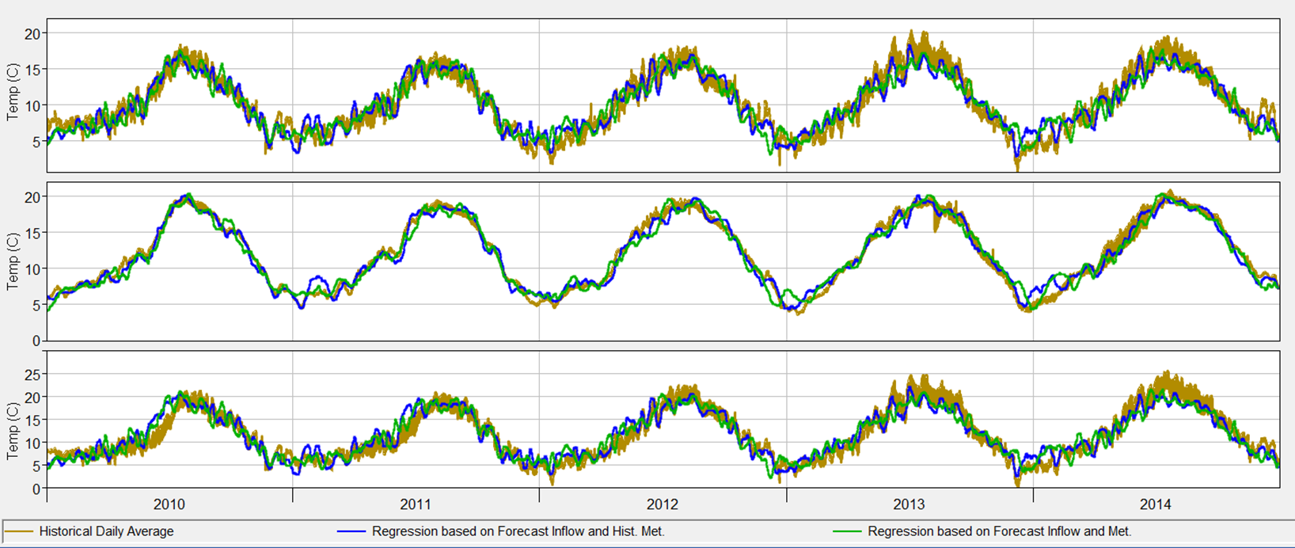
Figure 3-4. Shasta Lake tributaries: Sacramento, McCloud, and Pit Rivers inflow temperatures for historical average, estimated based on regressions using forecast inflow and historical meteorology (air temperature) and forecast meteorology (air temperature): 2010-2014.

Type D: Boundary Conditions – Meteorology
Uncertainty associated with forecast of meteorology incorporates Type A, B, and C uncertainty, plus an estimated meteorology forecast. As a proxy for an hourly meteorology, the monthly average air temperature was computed from the historical meteorology data for each month in the forecast simulation. This average monthly air temperature was used to select a representative monthly meteorology (hourly) from one year in the period of record. For example, if the March 2000 average monthly air temperature was 63ºF (17.2ºC), the March average monthly air temperature from the remaining 19 years (exclusive of 2000) that was closest to the March 2000 value was selected as the estimated meteorology forecast. Therefore, in this case, the hourly data from the selected March was used in March 2000. This process was repeated for all months in all years. An alternate meteorology data series was created that was similar (based on average monthly air temperature) but did not directly match the historical simulation year. An example is shown in Figure 3-5.
For meteorological boundary conditions – air temperature, atmospheric pressure, humidity, shortwave radiation, and wind speed –methods of preparing data that are under consideration include position analysis and Local 3-Month Temperature Outlook (L3MTO) analysis. These methods are currently under development or consideration. For this exercise a proxy was used wherein the historical monthly average air temperature for each month was sampled to select a representative month of meteorology data from one of the other years of the 20-year calibration record.

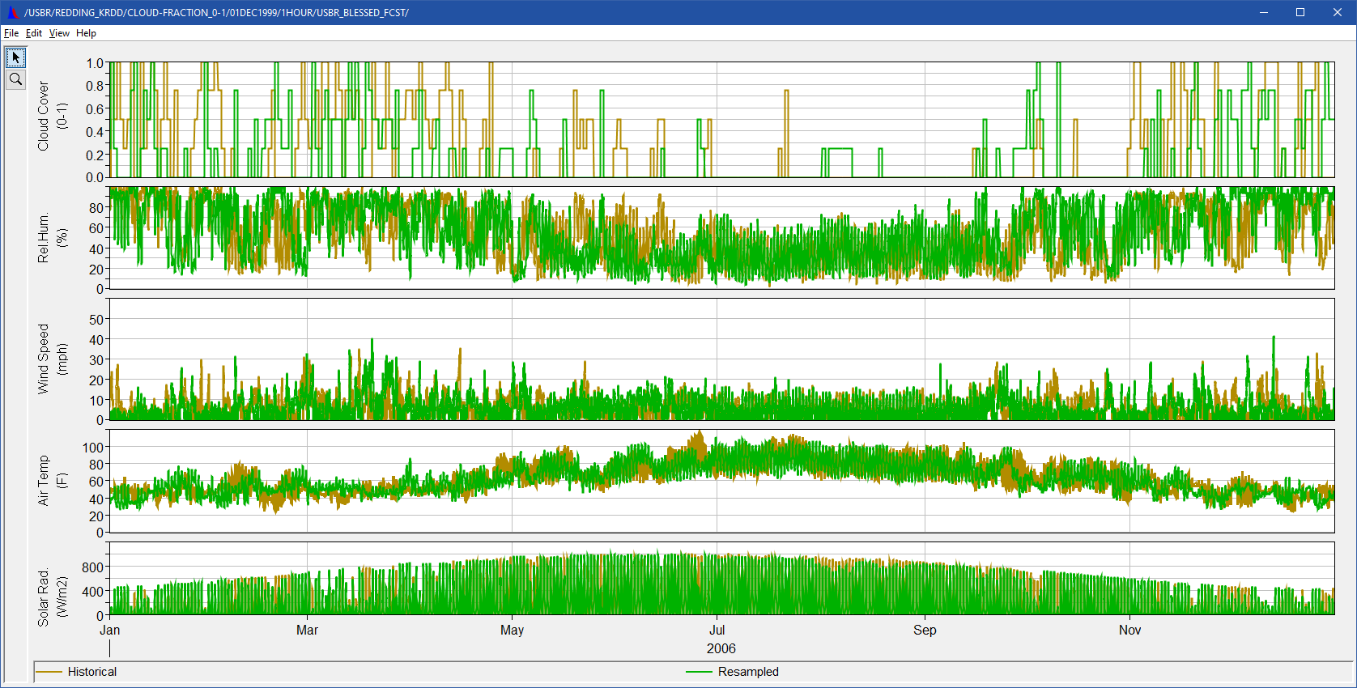
Figure 3-5. Historical and resampled meteorology applied to the Type D forecast uncertainty determine Shasta Lake inflow temperatures for the Sacramento, McCloud, and Pit Rivers , estimated based on regressions using forecast inflow and historical meteorology (air temperature) and as the forecast meteorology boundary condition for cloud cover, relative humidity, wind speed, air temperature and solar radiation (top to bottom): 2006.

Other Assumptions
Boundary conditions (temperature and flow) remained as during calibration for all simulation types for upper Clear Creek inflows into Whiskeytown Lake, inflow from the Spring Creek Diversion Dam into Keswick Reservoir, and downstream Sacramento River inflows (Cow Creek, Cottonwood Creek, Battle Creek). Diversion at the ACID dam on the Sacramento River also remained as is during calibration for all simulation types.
Boundary conditions of inflows into Trinity Lake and the Trinity River were selected from calibration (historical) boundary conditions in a manner similar to meteorology (e.g., historical monthly values were selected based on the closest -average monthly air temperature. Because calibration (historical) inflow temperatures to Trinity Lake and the Trinity River were already generated from daily regressions (as opposed to observations), this method is functionally similar to the method used to generate forecast Shasta Lake inflows temperatures for uncertainty analysis.

Results: ResSim
Uncertainty among the four WTMP simulation types (A, B, C, and D) was generated using up to 20 annual simulations across the hindcast years of 2000-2019. Figure 3-6 outlines the process of generating 95% confidence intervals among the four simulation types that measure different aspects of model uncertainty (labeled Uncertainty Results). Here we define a ‘bias’ as an instance of the difference of simulated –(minus) observed values. The scripting operation of ResSim facilitated the generation and analysis of over 240 individual simulations. Uncertainty was estimated by pooling bias (the difference between modeled and observed daily average temperatures) across months for up to 20 annual simulations. Standard deviations of these pooled daily biases were calculated and are reported as 95% confidence intervals.
Simulations were initialized at three different start months (March, May, July) to test the uncertainty of shorter and longer forecast periods, that translates to less or more information about the state of the cold pool, respectively. Simulations were initialized on the date of measured Shasta Lake vertical profiles and used observed temperatures, if those observations occurred within 10 days of the simulation start; otherwise, they were initialized to ResSim calibration/validation model results from the simulation start date. The remaining components of the Upper Sacramento WTMP study were similarly initialized.
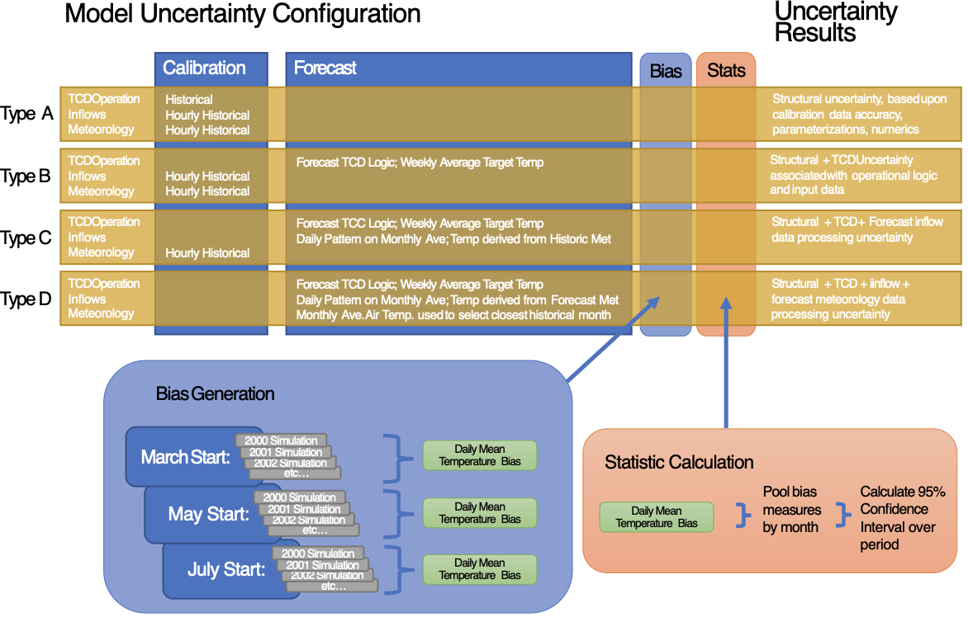
Figure 3-6. Diagram of model uncertainty estimation for ResSim WTMP.
Example time series of Shasta Dam outflow temperature observations and from each type of uncertainty simulation for two example years (2014, 2018) are shown in Figure 3-7 and Figure 3-8. In both years, monthly average outflows (used in type C, D forecast simulations) often permit smoother changes in temperature surrounding TCD gate change operations compared to the calibration simulation. The forecast TCD operations in ResSim generally reflect the historical TCD gate operations (e.g., in 2014, March start, Figure 3-9).
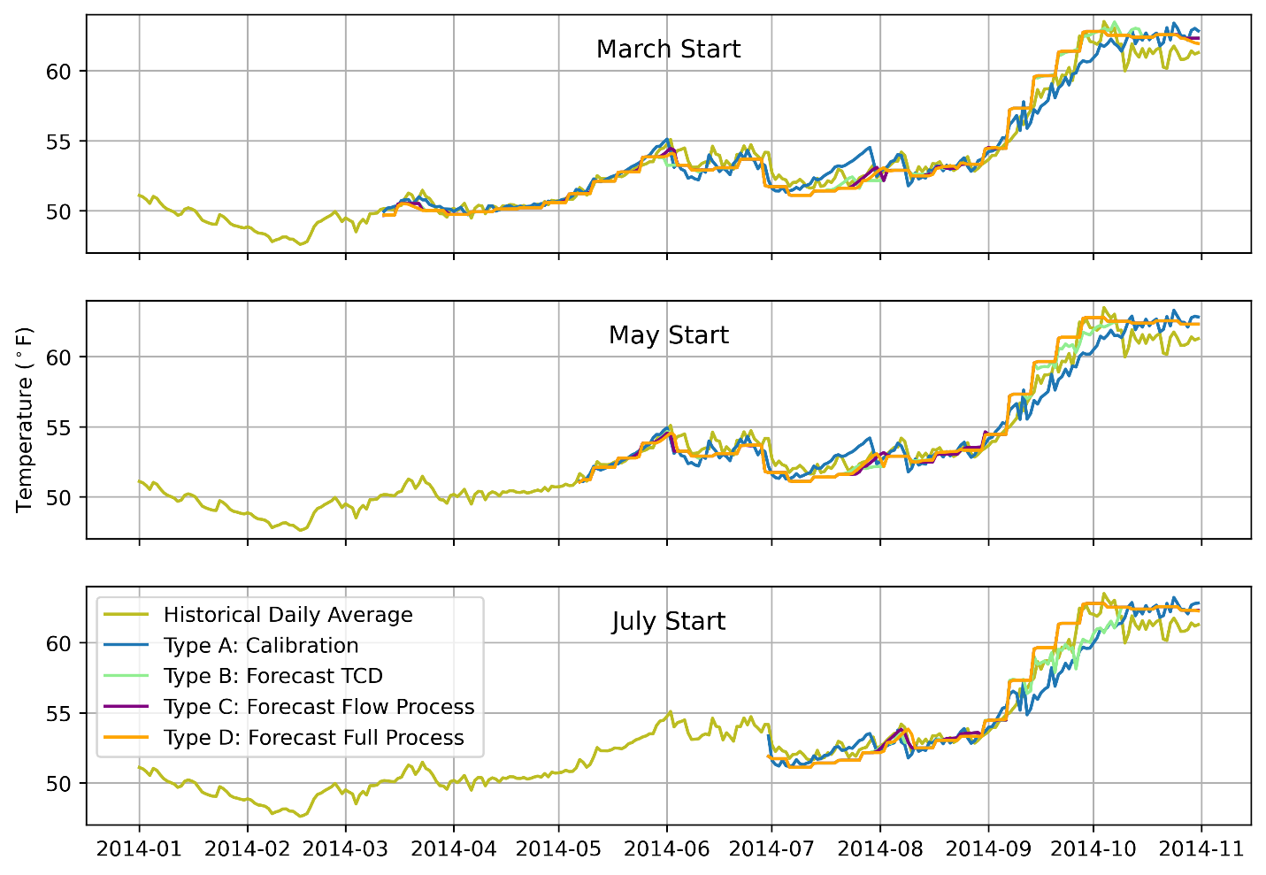
Figure 3-7. Example simulation temperature results for all simulation types, Shasta Dam outflow: 2014.
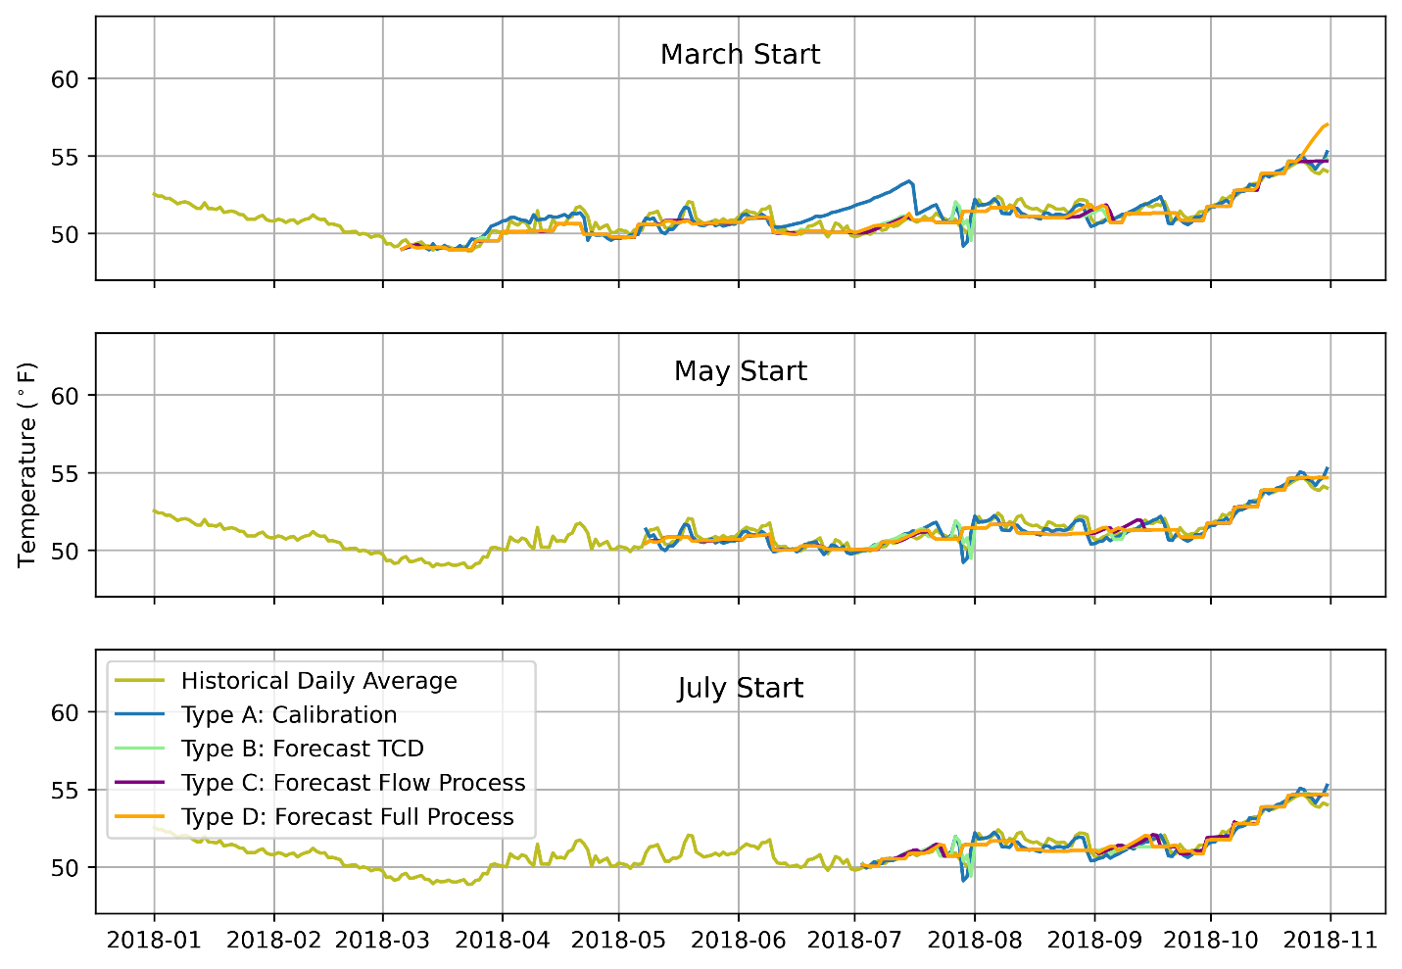
Figure 3-8. Example Simulation Result for all simulation types, Shasta Outflow Temperature: 2018.
Figure 3-9. Example Observed and Modeled (Forecast) Shasta TCD gate configuration: 2014.
Observed and simulated daily average temperatures generated for the ResSim uncertainty analysis are presented for forecast simulation types B, C, and D, in Figure 3-10 through Figure 3-12, respectively. Each figure contains two plots. The upper plot presenting Shasta Dam outflow temperature computed for the given simulation type for each simulation year (solid lines – termed samples) and the corresponding historical daily average temperature (dashed lines – termed observations). The lower plots include the difference between the daily average Shasta Dam outflow temperature simulation result minus the historical daily average temperature (temperature bias). Type B March 1 start simulations show the modeled Shasta Dam outflow temperatures tracking observed temperatures well, with occasional short-duration negative and positive biases associated with forecast Shasta Dam TCD gate change operations. Biases are generally reduced after June, compared to springtime. Type C and D biases are similar in overall magnitude to Type B. For year 2000 for Type C, and years 2000, 2018 for Type D simulated temperatures trend notably warmer in autumn.
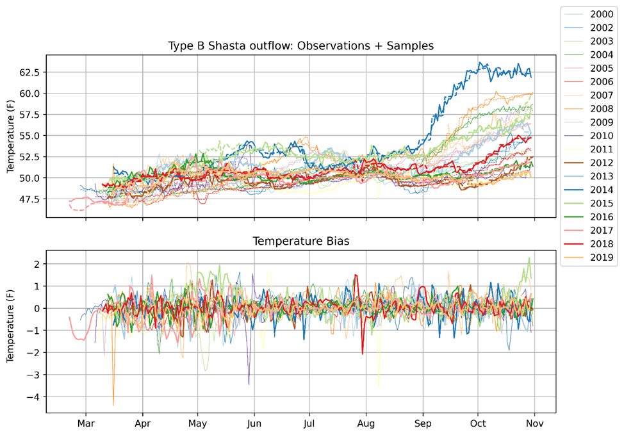
Figure 3-10. Shasta Dam outflow temperature and bias (ºF) Type B Simulation Results, 2000-2019 March Start. Top panel: Historical (solid) and Modeled (dashed) daily mean temperatures. Bottom panel: Difference in daily mean temperature, Simulated – Historical.

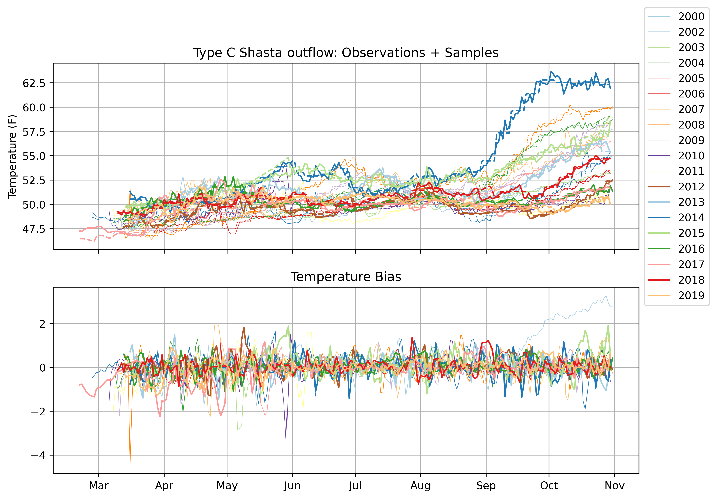
Figure 3-11. Shasta Dam outflow Temperature and bias (ºF) Type C Simulation Results, 2000-2019 March Start. Top panel: Historical (solid) and Modeled (dashed) daily mean temperatures. Bottom panel: Difference in daily mean temperature, Simulated – Historical.

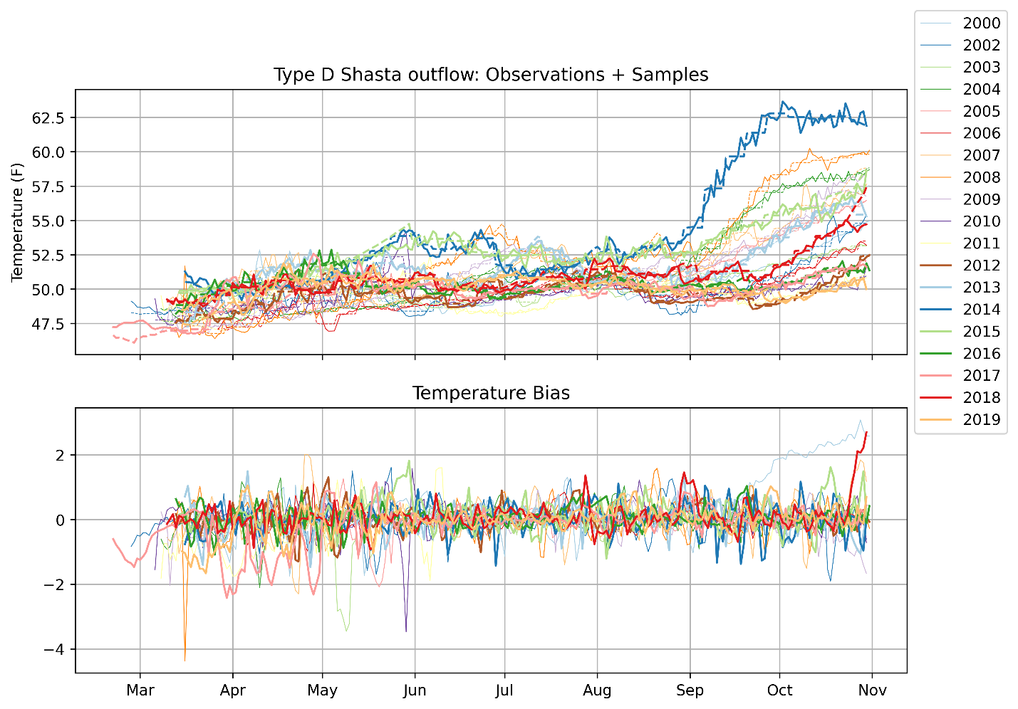
Figure 3-12. Shasta Dam outflow temperature and bias (ºF) Type D Simulation Results, 2000-2019 March Start. Top panel: Historical (solid) and Modeled (dashed) daily mean temperatures. Bottom panel: Difference in daily mean temperature, Simulated – Historical.
Uncertainty results are reported for temperatures at the Shasta Dam outflow, Keswick Dam outflow, and Sacramento River above Clear Creek. Shasta Dam outflow model uncertainty confidence intervals are less than +/- 1.5ºF (+/- 0.8ºC) under calibration and forecast simulation types. Shasta Dam outflow uncertainty is larger among all simulation types in spring, generally due to calibration errors in stratification timing. During the late spring and early summer, calibration uncertainty of the Shasta Dam outflow temperature is higher than forecast simulations for March and May starts, similar to W2 results from 2018. During this period, gate change operations cause differences between the simulation types. In October, uncertainty among the forecast types is larger, associated with accumulating differences in cold pool volumes associated with forecast-type boundary conditions (Figure 3-13). Mean bias of the Shasta Dam outflow temperatures is less than 0.25ºF (0.1ºC) in all months and for all simulation types, indicating uncertainty is centered around observed temperatures (Figure 3-14).

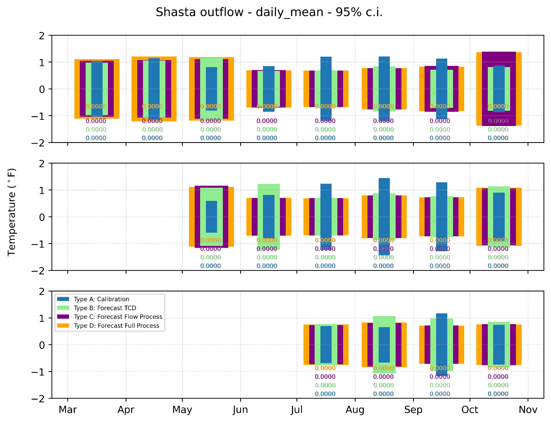
Figure 3-13. Shasta Dam outflow temperature monthly confidence intervals by simulation type. Vertical height of monthly box = 95% confidence interval. Numbers below box show p-value of normality test. Samples are the simulated daily mean temperature minus historical daily mean. The top, middle, and bottom panels and for March, May, and July start simulations, respectively.

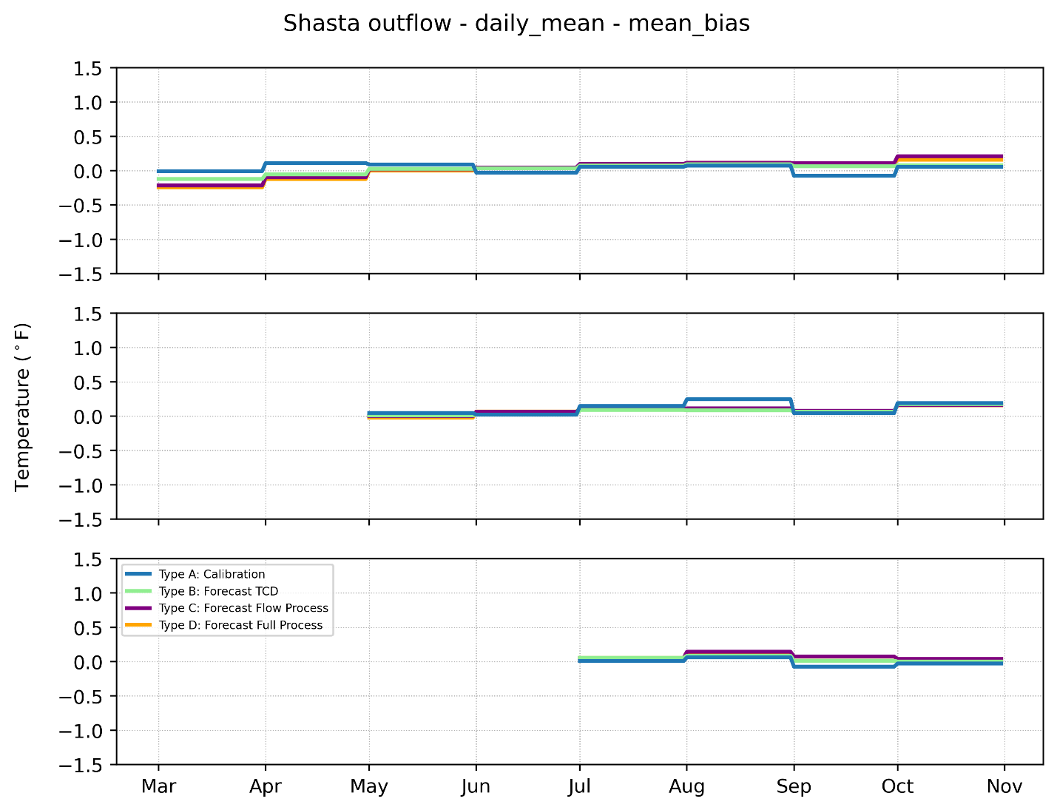
Figure 3-14. Shasta Dam outflow temperature monthly mean bias by simulation type. Samples are the simulated daily mean temperature minus historical daily mean. The top, middle, and bottom panels and for March, May, and July start simulations, respectively.
Keswick Dam outflow model uncertainty confidence intervals are less than +/- 2.0ºF (1.1ºC) under calibration and forecast simulation types. Uncertainty in Keswick Dam outflow temperature generally follows the upstream patterns of uncertainty in Shasta Dam outflow temperatures, except it is generally larger due to additional uncertainty introduced by inflows from Whiskeytown Lake and longer exposure to forecast boundary conditions (Figure 3-15). There is an expected pattern of decreasing uncertainty as the start date is moved later in the year, as initial conditions more correctly specify the cold pool and simulations are shorter, resulting in less accumulated error. The mean bias of model uncertainty in Keswick Dam outflow temperature is positive, reflecting the positive bias in calibration (Figure 3-16).

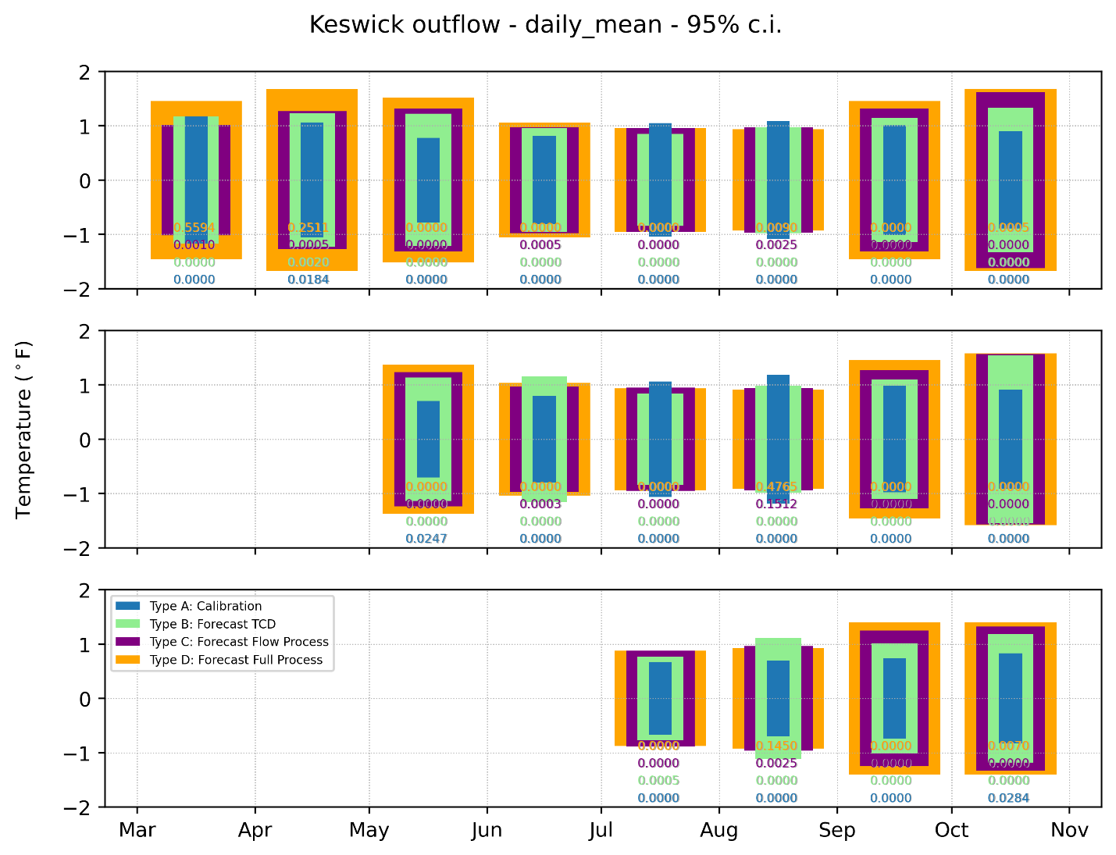
Figure 3-15. Keswick Dam outflow temperature monthly confidence intervals by simulation type. Vertical height of monthly box = 95% confidence interval. Numbers below box show p-value of normality test. Samples are the simulated daily mean temperature minus historical daily mean. The top, middle, and bottom panels and for March, May, and July start simulations, respectively.

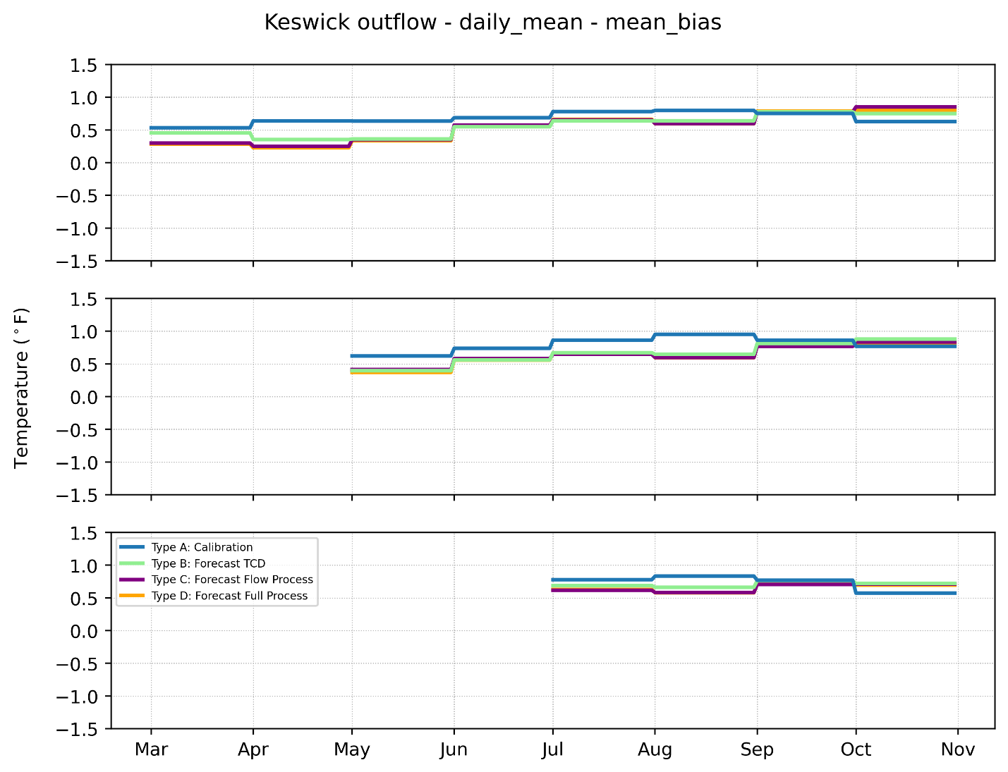
Figure 3-16. Keswick Dam outflow temperature monthly mean bias by simulation type. Samples are the simulated daily mean temperature minus historical daily mean. The top, middle, and bottom panels and for March, May, and July start simulations, respectively.
Sacramento River above Clear Creek model uncertainty confidence intervals are less than +/- 2.0ºF (1.1ºC) under forecast simulation types starting after May 1, but slightly exceed 2.0ºF (1.1ºC) in the spring during March start simulations. Calibration uncertainty is less than +/- 1.0ºF (0.5ºC) except during March and April. Like temperature at Keswick Dam, uncertainty in Sacramento River at Clear Creek temperatures generally follow the upstream patterns of uncertainty in Shasta Dam outflow temperatures, with added forecast uncertainty reflecting the downstream location (Figure 3-17). Decreasing uncertainty as the start date is moved later in the year is apparent. The mean bias of model uncertainty in Sacramento River above Clear Creek outflow temperature is positive in summer, reflecting the positive bias in calibration at that time (Figure 3-18).

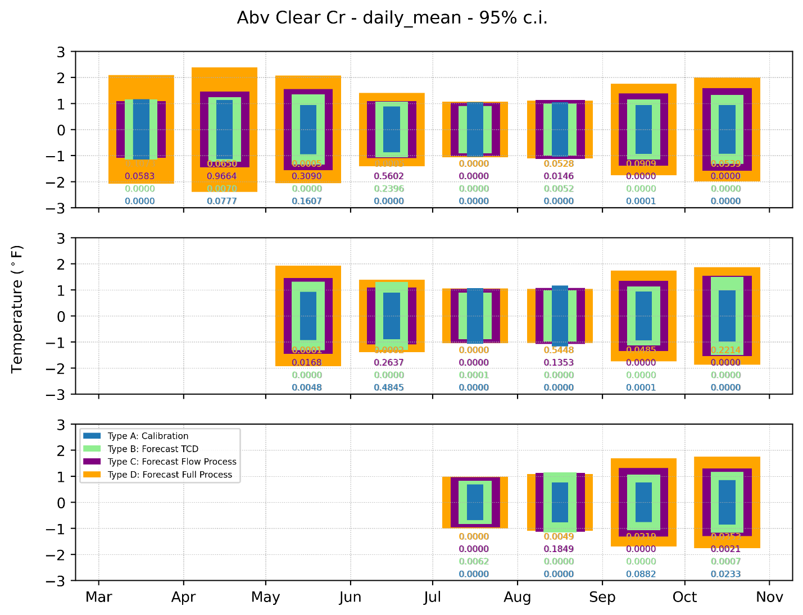
Figure 3-17. Sacramento River above Clear Creek Temperature monthly confidence intervals by simulation type. Vertical height of monthly box = 95% confidence interval. Numbers below box show p-value of normality test. Samples are the simulated daily mean temperature minus historical daily mean. The top, middle, and bottom panels and for March, May, and July start simulations, respectively.

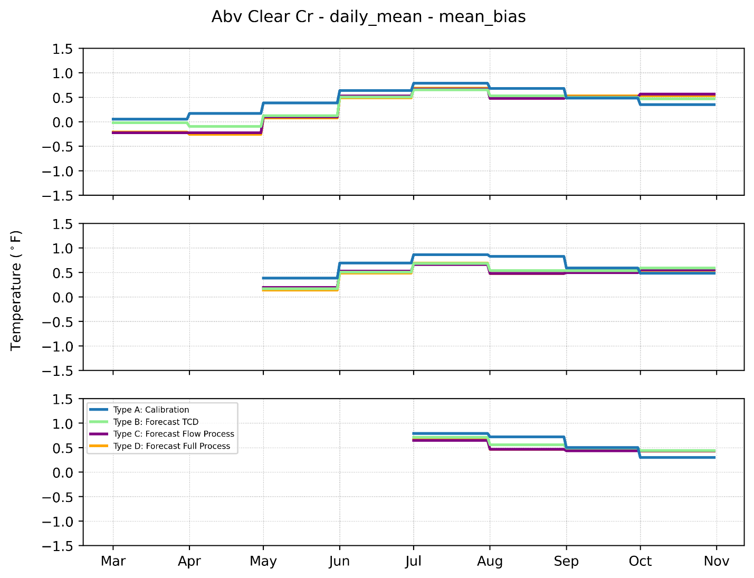
Figure 3-18. Sacramento River above Clear Creek Temperature monthly mean bias by simulation type. Samples are the simulated daily mean temperature minus historical daily mean. The top, middle, and bottom panels and for March, May, and July start simulations, respectively.

Results: CE-QUAL-W2
Application of the forecasting process uncertainty was also assessed with CE-QUAL-W2 for a limited scope in time but at the same locations Shasta, Keswick, and the upper Sacramento River above Clear Creek as the ResSim example. A single year (2018) was simulated with two start dates: March 1 and May 1. The WTMP was designed to utilize ResSim as the computationally efficient element for multiple simulations to assess a wide range of options or conditions and the more detailed, but computationally intensive model CE-QUAL-W2 to focus on selected periods or years. The graphics represented herein are time-series summaries for a single year without 95 percent confidence intervals (as presented for ResSim) because of the small sample size.
Using the same approach outlined above for Type A through D uncertainty, time series of Shasta Dam outflow were developed.

March 1 Start Date
For a March 1 start date the differences between all forecast uncertainty types and the measured Shasta Dam outflow temperature are on the order of 1ºF (0.5ºC), and the forecasting process error introduced by Type B, C, and D errors is approximately the same magnitude as the calibration error (Type A) (Figure 3-19). Monthly average conditions further support this result (Figure 3-20).
There are several facets of these results to consider. From March into early May there is the potential for considerable variability in hydrology and meteorology. The reservoir typically experiences the initiation of seasonal stratification in early April and the reservoir is thermally stratified by May 1. The introduction of automated TCD gate selection (blending) by CE-QUAL-W2 in Type B results shows a smaller difference between simulated and measured observations because the model is no longer restricted by historical gate settings. As flow disaggregation (Type C) and meteorology uncertainty (Type D) is included, the difference between simulated and measured results is sometimes slightly higher or slightly lower than Type B. Because the model in each Type B, C, and D simulation is free to select TCD configurations to meet the downstream target, added uncertainty is generally modest. Of note is the sudden temperature change around August 1 (Figure 3-19) is an outcome of the TCD logic and user set constraints based on the number of days (three days) that must pass prior to the downward progression of gates for temperature control. Ongoing refinements to the logic can remedy this outcome.)

May 1 Start Date
Differences between all forecast uncertainty types and the measured Shasta Dam outflow temperature are smaller for the May 1 start date (Figure 3-21). Starting two months later reduced the uncertainty surrounding the variability of March and April with regards to inflow, inflow temperatures, thermal stratification inception and evolution. A large fraction of the annual inflow occurs before May 1 in many years. Further, Shasta Lake cold water pool replenishment typically ends before May 1 because the reservoir has already stratified by this date. Model performance on a monthly average basis indicates the overall forecast error (Type B, C, and D) is typically less than or equal to the calibration error (Type A) (Figure 3-22).
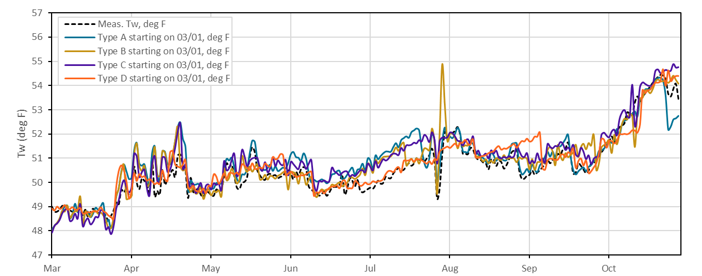
(a)

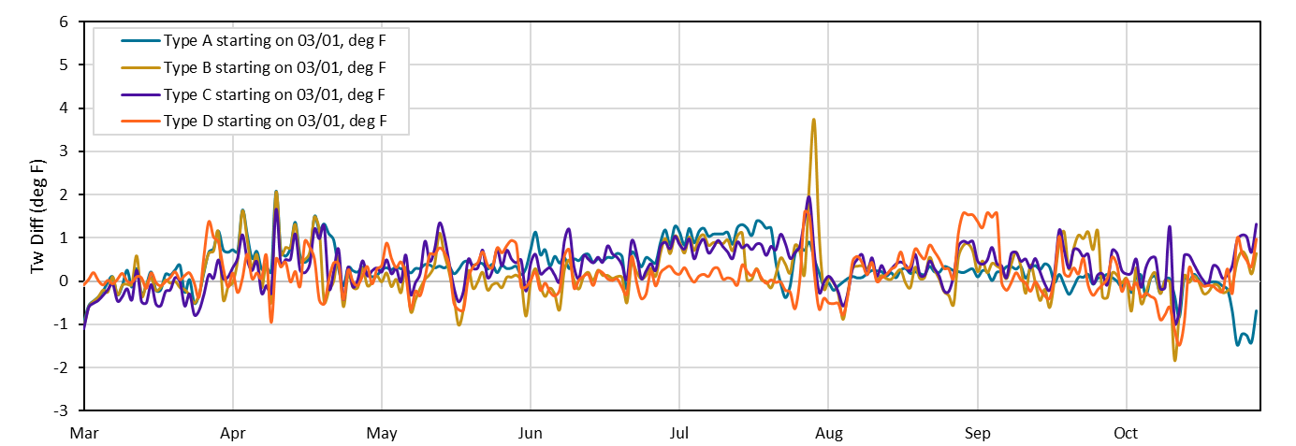
(b)
Figure 3-19. Daily average Shasta Dam release temperature (a) for Type A, B, C, and D forecast uncertainty compared to the measured temperature, and (b) for differences between measured and Type A, B, C, and D forecast uncertainty: March 1, 2018 start date.
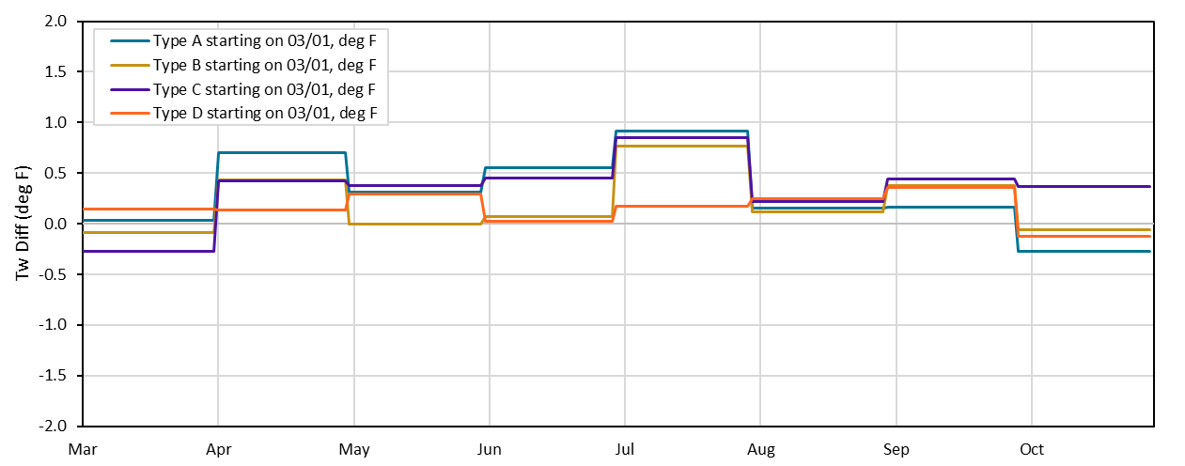
Figure 3-20. Monthly average Shasta Dam release temperature for Type A, B, C, and D forecast uncertainty minus measured release temperature for a March 1, 2018 start date.
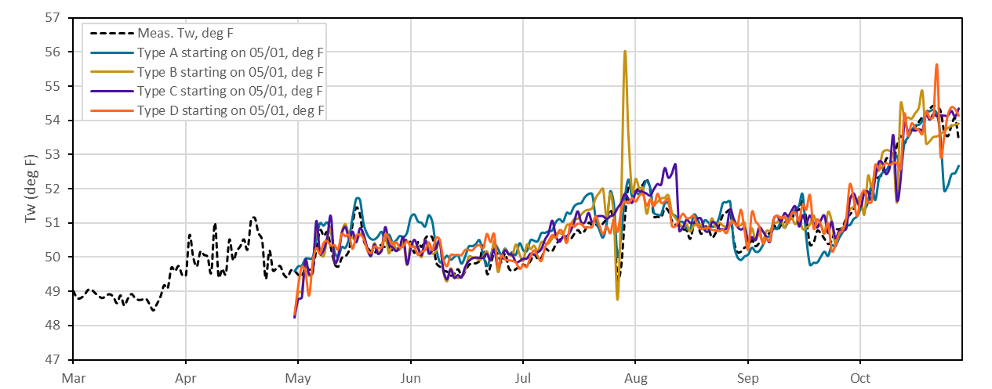
(a)
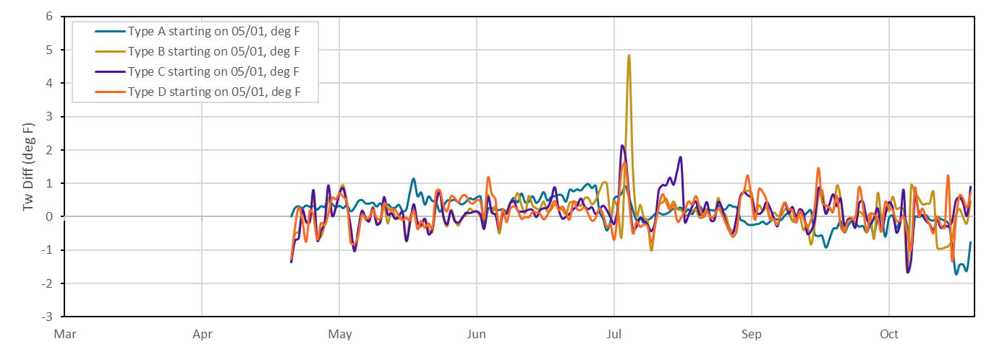
(b)
Figure 3-21. Daily average Shasta Dam release temperature (a) for Type A, B, C, and D forecast uncertainty compared to the measured temperature, and (b) for differences between measured and Type A, B, C, and D forecast uncertainty for a May 1, 2018 start date.
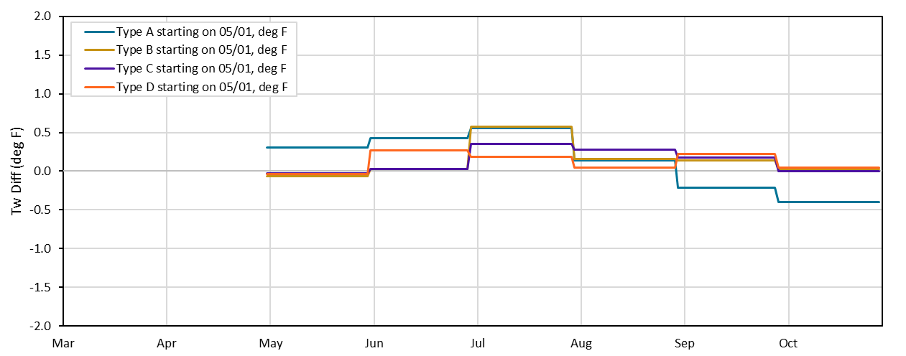
Figure 3-22. Monthly average Shasta Dam release temperature for Type A, B, C, and D forecast uncertainty minus measured release temperature for a May 1, 2018 start date.

Shasta Lake Thermal Profile
Cold water pool dynamics respond differently to the Type A, B, C, and D simulations. Monthly Shasta Lake profiles June 1 through October are shown in Figure 3-23 for a March 1 start date. The measured and Type A are quite close, representing the calibrated model tracks measured data. Type B simulations, where the TCD is automatically selected similarly tracks the measured data and Type B simulations, indicating that the gate selection logic also tracks historic conditions. Disaggregating the flows and assigning inflow temperatures based on these disaggregated flows in Type C suggest that this in-reservoir thermal structure has changed in response to this modified boundary conditions and the TCD automatic gate selection has likewise adjusted to meet tailbay temperatures, resulting in a temperature profile that deviated from the measured (and Type A and B). When the meteorological data and associated inflow temperature are also modified (Type D) there is a similar deviation from measured, but the magnitude and shape of the profile differs from the Type C simulation. These results illustrate that while the automatic gate level selection in the TCD logic will maintain a Shasta Dam tailbay temperature at or near the target, there is a compensating effect on the thermal structure of the reservoir. In this instance, there was sufficient cold water pool storage in all simulations to maintain the Shasta Dam tailbay target temperature. The simulations illustrate that model uncertainty associated with the runoff forecast can impact cold water pool, and that consideration of model uncertainty is important in the seasonal forecast. Additional work in this area is recommended to develop an appropriate estimate of this uncertainty across a range of conditions that would assist operators managing the TCD and inform resource managers that make decisions based on early season forecasts.

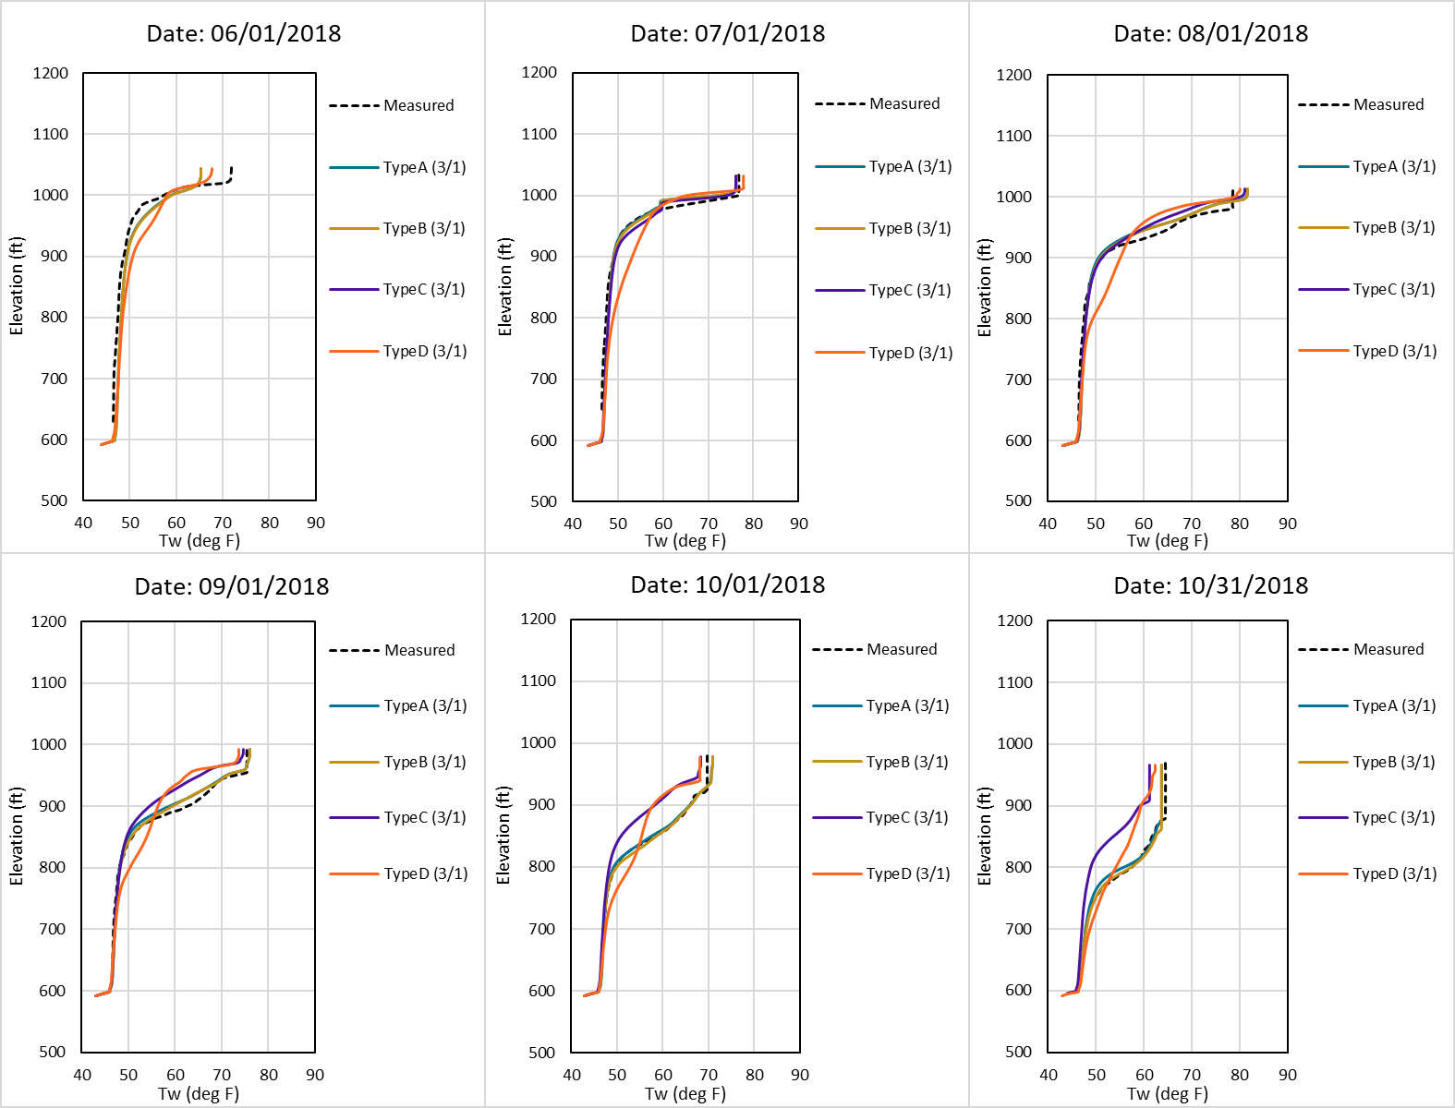
Figure 3-23. Monthly Shasta Lake profiles June 1 through October: March 1, 2018 start date.

Summary
- These findings indicate that uncertainty introduced. in the forecast is on the same order of magnitude as the calibration error. Forecasts starting later in the spring (May 1) generally have less uncertainty through the temperature management season because the variability present in March and April are eliminated, i.e., the variability in March and April is no longer a necessary part of the forecast input. The automatic TCD gate selection in the models allows the model to track Shasta Dam tailbay temperatures closely. However, there is a change within the reservoir thermal structure (i.e., changes in temperature profile) from these forecasting assumptions that impact the cold-water pool within the reservoir. Exploring a range of simulations to assess these in-reservoir cold water differences and develop metrics useful to operators and decisionmakers is a potential future collaborative activity.
This page intentionally left blank.

Conclusion
The WTMP was developed to support Reclamations planning and management activities in the Central Valley. Modeling analyses are an important element in evaluating how operational decisions and various influencing factors can affect water temperature in CVP reservoirs and downstream river rivers, providing invaluable information to decision makers. Identifying and exploring model uncertainty is an important step in the final stages of WTMP development. Reclamation (2023g) identified sources of uncertainty, including model conceptualization, model development, data, and model parameterization. These modeling uncertainty elements were included in the final calibrated model. Certain model applications, such as hindcasting and validation that are based on historic observations, include uncertainty consistent with the calibrated model. Other applications include additional sources of error and thus model uncertainty.
Forecast uncertainty can occur in model input data or within the model representation. Error in the forecast flow, operations, meteorology, estimated initial conditions or other input estimates are external to the model and were not examined herein. This analysis examined the uncertainty introduced through data processing steps required to prepare boundary conditions for forecast simulations and by the additional model logic required to operate reservoir temperature control devices to meet prescribed temperature targets. Forecast data processing uncertainty was examined using model simulations representing a set of prescribed conditions for four uncertainty types:
- Calibrated Model Uncertainty – historical boundary conditions were used as prepared for the calibration/validation simulation. This represents a baseline condition where initial conditions, boundary conditions, TCD gate settings are known, and the model uncertainty is defined by the calibration.
- Selective Withdrawal Logic Uncertainty – uncertainty associated with model determined gate settings for the TCD (Shasta Dam) versus historical gate settings. Type B uncertainty includes calibration uncertainty.
- Flow Disaggregation Uncertainty – Type C includes changes from Type B, above, plus processing of reservoir inflows and releases in a manner similar to the process used in the operations forecast monthly data. Reservoir inflow temperatures were subsequently estimated based on the downscaled daily inflow time series and the historical meteorologic record.
- Meteorology Forecast Uncertainty – Type D uncertainty includes all changes from Type C, above, plus an estimated meteorology forecast. Reservoir inflow temperatures were subsequently estimated based on the downscaled daily inflow time series and the estimated meteorology forecast.
A series of simulations were performed using the WTMP ResSim model for the Upper Sacramento System for each of these four uncertainty types considering forecast start times at the beginning of March, May, and July for each of the years 2000 through 2019. In all cases the boundary conditions were derived using forecast data processing techniques from historical data to represent “perfect forecasts” despite any inherent associated errors. Historical daily average reservoir release and river temperatures can therefore be used as the basis for computing model error under each uncertainty type. Summary conclusions from this analysis include the following.
- Early forecasts tend to have moderately greater uncertainty in late fall predictions. This is an expected result as later forecasts are based on observed reservoir thermal profiles once the effects of spring inflows and reservoir warming have established stratification in the reservoir. If the forecasts begin earlier in the year, the onset of stratification must be simulated based on the estimated forecast inflows and meteorologic data.
- When the model is allowed to operate the TCD to meet target temperatures, error is typically reduced mid-year but possibly at the expense of missing targets later in the year. Meeting release temperature targets requires balancing TCD shutter openings with the thermal profile in the reservoir. While the temperature models generally do a good job simulating the evolution of reservoir thermal profiles through summer and fall season, leaving the model free to make decisions regarding TCD operations can result in more precisely meeting temperature targets because the operation logic is responding the modeled thermal profile, rather than accepting an historic operation that was managed based on the observed thermal profile. Through the simulation year, the incremental differences in operation can result in a different thermal profile at the end of the temperature management season, which can affect the ability of the TCD to meet targets.
- Estimation of meteorologic data has a relatively greater impact on downstream locations.
Reservoir release temperatures are a function of many factors including the flexibility of withdrawal structures to make releases from various levels in the reservoir depending on the reservoir vertical thermal profile, which in turn is a function of inflow timing, volume, and temperature, previous reservoir releases, vertical mixing within the reservoir, and heat exchange at the reservoir surface. Whereas downstream river temperatures are a function of inflow temperature and heat exchange as the water travels through river, which is much more responsive to meteorologic conditions due to its smaller volume and depth.
- The “structural” uncertainty of the calibrated model as measured by 95% confidence interface is generally on the order 0.5ºC (0.9ºF). Using the best available boundary condition data, the calibrated model provides a good representation of water temperature at reservoir release points and at downstream locations. The Upper Sacramento System is a large and complex river-reservoir system, and even with extensive data collection there are still some approximations/uncertainties in geometry, boundary conditions, and physical processes in around complex structures such as the Shasta TCD which contributed to “structural” model uncertainty.
- Considering all aspects of the forecast data processing, the 95% confidence interval at the Shasta outflow is similar and sometimes lower than the calibration simulation, and at the Sacramento River above Clear Creek Station it increases to approximately 1ºC (1.8ºF), which is not an excessive increase. The primary conclusion of this analysis is that the forecast data processing techniques do not introduce an excessive increase in uncertainty about a single forecast simulation. This demonstrates that the model will be a useful tool in evaluating relative impact of alternate operational forecasts.
- CE-QUAL-W2 findings are consistent with the ResSim findings and indicate that uncertainty introduced in the forecasting process is on the same order of magnitude as the calibration error. Forecasts starting later in the spring (May 1) generally have less uncertainty through the temperature management season because the variability present in March and April is eliminated, i.e., the variability in March and April is no longer a necessary part of the forecast input. The automatic TCD gate selection in the models allows the model to track Shasta Dam tailbay temperatures closely. However, there is a change within the reservoir thermal structure (i.e., changes in temperature profile) from these forecasting assumptions that impact the cold-water pool within the reservoir. Exploring a range of simulations to assess these in-reservoir cold water differences and develop metrics useful to operators and decisionmakers is a potential future collaborative activity.
The WTMP has been successfully applied to a variety of Reclamation modeling activities as part of the overall testing (calibration, forecasting, long-term planning). As Reclamation implements the framework into their temperature management activities, the use of the platform to support these activities, as well as other analyses is expected to provide additional insight and improve temperature management activities into the future including additional locations and incorporating uncertainty associated with hydrologic, operations, and meteorologic forecasts.

This page intentionally left blank

References
California Department of Water Resources (DWR), State Water Resources Control Board (SWRCB), Department of Fish and Wildlife (DFW), Department of Conservation - California Geological Survey (CGS). 2022. California Stream Gaging Prioritization Plan 2022. (https://www.waterboards.ca.gov/waterrights/water_issues/programs/stream_gaging_plan/docs/sb19-report.pdf)
California Water and Environmental Modeling Forum (CWEMF). 2021. Protocols for Water and Environmental Modeling. November 19.
Deas, M.L., I.E. Sogutlugil, A.E. Bale, S.K. Tanaka. 2020. Shasta Lake and Keswick Reservoir Flow and Temperature Modeling – Development Report. Prepared for the Sacramento River Settlement Contractors. December.
U.S. Bureau of Reclamation (Reclamation). 2023a. Water Temperature Modeling Platform: Data Development. June.
U.S. Bureau of Reclamation (Reclamation). 2023b. Water Temperature Modeling Platform: Data Management Plan. May.
U.S. Bureau of Reclamation (Reclamation). 2023c. Water Temperature Modeling Platform: Framework Selection. May.
U.S. Bureau of Reclamation (Reclamation). 2023d. Water Temperature Modeling Platform: Model Development, Calibration, Validation, and Sensitivity Analysis. July.
U.S. Bureau of Reclamation (Reclamation). 2023e. Water Temperature Modeling Platform: Model Selection and Design. May.
U.S. Bureau of Reclamation (Reclamation). 2023f. Water Temperature Modeling Platform: Model Implementation. July.
U.S. Bureau of Reclamation (Reclamation). 2023g. Water Temperature Modeling Platform: Model Uncertainty - Sources. July.
U.S. Bureau of Reclamation. 2023h. DRAFT Sacramento River Temperature Management Plan for Water Year 2023. April 26.
U.S. Bureau of Reclamation (Reclamation). 2020. Temperature Model Development, Solicitation 140R2020Q0064. Central Valley Operations Office, 3310 El Camino Avenue, Suite 300, Sacramento, CA 95821-6377. July 2.
U.S. Bureau of Reclamation (Reclamation). 2017. Water Temperature Management in Reservoir-River Systems through Selective Withdrawal. Reference Technical Memorandum for Central Valley Project Operation, California. September.

Pit River used an 18-day running average.

